

Sample Questions for the Rutgers – New Brunswick Math Placement Test
(This is not intended for Rutgers Camden or Rutgers Newark students)
Sample questions are listed below (answers appear after all questions below) – remember, the test is comprised of open-ended questions (not multiple choice). Not all topics will be presented.
1. $\frac{2}{9}+\frac{5}{6}∙\frac{1}{2}$ =
2. Solve for x: 2(x $-$ 4) = 4x + 5
3. Factor x² − 36
4. Solve for a: − $\frac{1}{2}a-\frac{2}{3}=\frac{3}{5}$
5. Factor 3x² − 14x + 8
6. Theater tickets to the Livingston Theater production cost $18 for students and $25 for non-students. If 320 tickets were sold, and the total sales of all of the tickets was $6719, how many student tickets were sold?
7. Express as a single fraction: 1 + $\frac{y-3x}{3x}+\frac{5x-2y}{4x}$
8. Write in simplified form: $\sqrt{32}$ − $\sqrt{2}$
9. Write in simplified form with positive exponents only: $\frac{x^{-2}x^{3}}{x^{4}}$ Assume x is a positive real number.

1 of 3
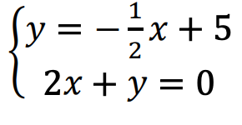
10. Solve the system:

11. Solve for x: $|3-2x|>4$
12. Simplify: express your answer with positive exponents only: x^{−3/2} x³ x^{1/3} Assume x is a positive real number.
13. Find the center and radius of the circle: x² +y² − 6x + 8y = 8
14. Sketch the graph of y = −2(x + 1)² − 2
15. Put in simplest radical form: $\sqrt[3]{32x^{7}y^{18}}$
16. If $f(x)= 2x^{2}-3x+5$ and $g(x)=\frac{2x}{5-x}$, then $f(g(3))$ =
17. Solve for x: log _{x} 64 = 3
18. Solve for x using base 10: 9^{x−4} = 7^{−3x}
19. For the right triangle below, find $sec θ$ exact (not decimal approximations): 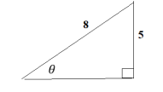
20. Solve for x: 2 cos²x = 1 + sin x for x in the interval [0,2π). Express your answer in radians in terms of π.
2 of 3
ANSWERS

1) $\frac{23}{36}$, 2) x = $-\frac{13}{2}$, 3) (x $-$ 6)(x $+$ 6), 4) $-\frac{38}{15}$, 5) (3x $-$ 2)(x $-$ 4), 6) 183
7) $\frac{15x-2y}{12x}$, 8) $3\sqrt{2}$, 9)$\frac{1}{x^{3}}$ , 10)$x=$ $-\frac{10}{3}$ , y = $\frac{20}{3}$ , 11) x < $-\frac{1}{2}$ or $x>$ $\frac{7}{2}$
12) ${x^{11/6}}^{}$ , 13) Center = (3,$-$ 4) , radius = $\sqrt{33}$
14)
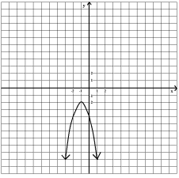

15) $2x^{2}y^{6}\sqrt[3]{4x}$, 16) 14 , 17) $x=4$ , 18) $x=\frac{4 log 9}{log 9 + 3 log 7}$
19) $\frac{8\sqrt{39}}{39}$ , 20) x = $\frac{π}{6}$ , $\frac{5π}{6}$, $\frac{3π}{2}$

3 of 3

